**To assign created skills to the workers**

1. Login to worker platform and click any worker whose id you want to note.  
   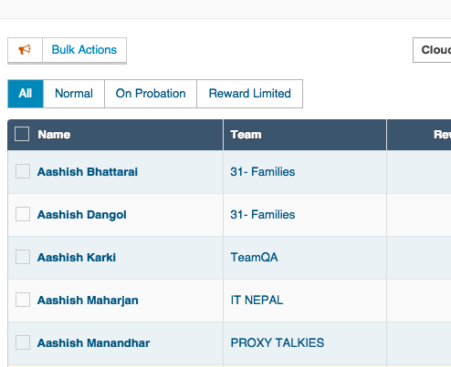
2. Copy the worker id from the URL like 528f7ff6863a99a87100ae5f and then go back to client platform and click Workers from right side.  
   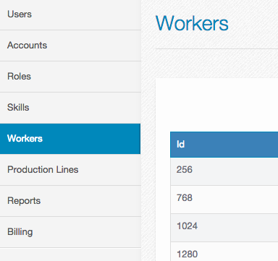
3. Then search the worker through the id you have just obtained from workers platform.  
   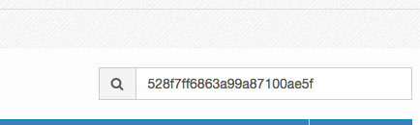
4. Then open the worker by clicking its id below identifier and click   
   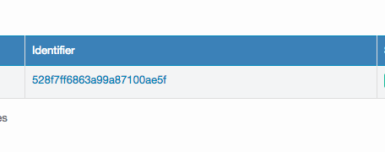
5. Then click + sign to add new skills. If it is already present then you can search.  
   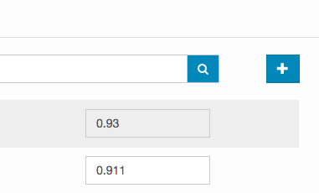
6. Next, choose the skills from the drop down and click Submit. Make sure you have already created skills earlier.  
   